Healthcare Appointment No-Show Analysis
A Data Analytics Project Report

1. Introduction
Healthcare appointment no-shows are a persistent problem across clinics and hospitals worldwide. When a patient books an appointment but doesn't show up — without canceling — it creates a ripple effect: wasted doctor time, longer wait times for other patients, and increased operational costs for the facility.
This project takes a closer look at that problem using real appointment data. The goal was to understand why patients miss appointments and which factors — waiting time, demographics, location, medical condition, or SMS reminders — are most connected to no-show behavior.
The analysis was done using Python for data processing and visualization, and Power BI for building interactive dashboards.

2. Project Objective
The main aim of this project was to analyze patterns in healthcare appointment attendance and identify the key drivers of no-show behavior. Specifically, the project set out to:
- Measure the overall no-show rate across the dataset
- Understand how waiting time between booking and appointment affects attendance
- Explore which age groups, genders, and weekdays have higher no-show rates
- Identify neighborhoods with the most missed appointments
- Evaluate whether SMS reminders make a difference
- Analyze the role of chronic medical conditions like diabetes

3. Dataset Overview
The dataset contains medical appointment records from a public healthcare system. Each row represents a single appointment and includes information about the patient and the appointment itself.
Key columns in the dataset:
Column | Description
AppointmentID | Unique identifier for each appointment
PatientID | Unique identifier per patient
Gender | Patient gender (Male / Female)
ScheduledDay | Date the appointment was booked
AppointmentDay | Actual appointment date
Age | Patient age
Neighbourhood | Location/area of the clinic
Scholarship | Whether the patient is enrolled in a welfare program
Hipertension | Whether the patient has hypertension
Diabetes | Whether the patient has diabetes
Alcoholism | Whether the patient has alcoholism
SMS_received | Whether a reminder SMS was sent (1 = Yes)
No-show | Target variable — "Yes" means the patient did NOT show up
Dataset Size: ~71,959 appointments across 80 neighborhoods

4. Data Cleaning and Preprocessing
Before jumping into analysis, the raw data needed cleaning. The following steps were performed:
Checked for missing values and duplicates: The dataset was checked for null values and duplicate rows. No missing values were found. Any duplicate rows detected were dropped.
Converted date columns: ScheduledDay and AppointmentDay were converted to proper datetime format using pandas so time-based calculations would work correctly.
Created the target variable as numeric: The No-show column (values "Yes"/"No") was mapped to a binary NoShowFlag column (1 = no-show, 0 = attended) for easier numerical analysis.
Extracted calendar features: ScheduledWeekday and AppointmentWeekday were derived from the date columns to support weekday-level analysis.
Created age groups: Patients were grouped into five age bands — Child/Young Adult (0–18), Young Adult (18–35), Adult (35–50), Senior (50–65), and Elder (65+) — to support cohort comparisons.
Removed invalid age records: Records with a negative age value were identified and removed.
Calculated waiting time: A new column WaitingDays was created by subtracting ScheduledDay from AppointmentDay. Records with negative waiting days (appointment before scheduling date — logically impossible) were removed.
Categorized waiting time: WaitingDays was binned into six categories — Same Day, 1–3 Days, 4–7 Days, 8–15 Days, 16–30 Days, and 30+ Days — for easier analysis and visualization.
Exported cleaned data: The final cleaned dataset was exported as healthcare_cleaned_final.csv for use in Power BI dashboards.
All preprocessing was done using pandas in Python.

5. Exploratory Data Analysis
The EDA phase involved analyzing the cleaned data with Python — using Matplotlib and Seaborn — to spot patterns before building the dashboards.
No-Show Rate: After cleaning, the overall no-show rate was calculated. Roughly 28.52% of appointments were no-shows — meaning more than one in four booked appointments went unattended.
Waiting Time: The clearest pattern in the data was the relationship between waiting time and attendance. A cross-tabulation of WaitingCategory vs No-show showed that the no-show rate increased steadily from approximately 21% for same-day appointments to over 33% for appointments scheduled 30 or more days in advance. Patients with shorter waiting periods consistently showed lower no-show percentages.
Gender: A count plot of gender vs no-show was generated. Female patients made up a larger share of total appointments, but the no-show behavior was analyzed across both genders.
Age: A box plot of age vs no-show was produced to compare the age distributions of patients who showed up vs those who didn't.
SMS Reminders: A count plot of SMS_received vs No-show and a cross-tabulation were both generated. The analysis showed that patients receiving SMS reminders still exhibited significant no-show behavior, suggesting reminders alone are not sufficient.
Scholarship (Welfare Assistance): A cross-tabulation showed that patients enrolled in financial assistance programs demonstrated slightly different attendance behavior compared to non-assisted patients. This variable was flagged as useful for dashboard segmentation.
Medical Conditions — Diabetes: A cross-tabulation of Diabetes vs No-show was performed. Patients with diabetes tended to attend appointments more consistently than the general population. This suggests chronic care patients may be more motivated to keep appointments.
Weekday Patterns: No-show rates were calculated by AppointmentWeekday. The output was reviewed across Monday through Sunday to identify which days had higher missed appointment percentages.
Neighborhoods: The top 10 neighborhoods by no-show rate were calculated and printed, identifying which areas had the highest percentage of missed appointments.

6. Dashboard 1
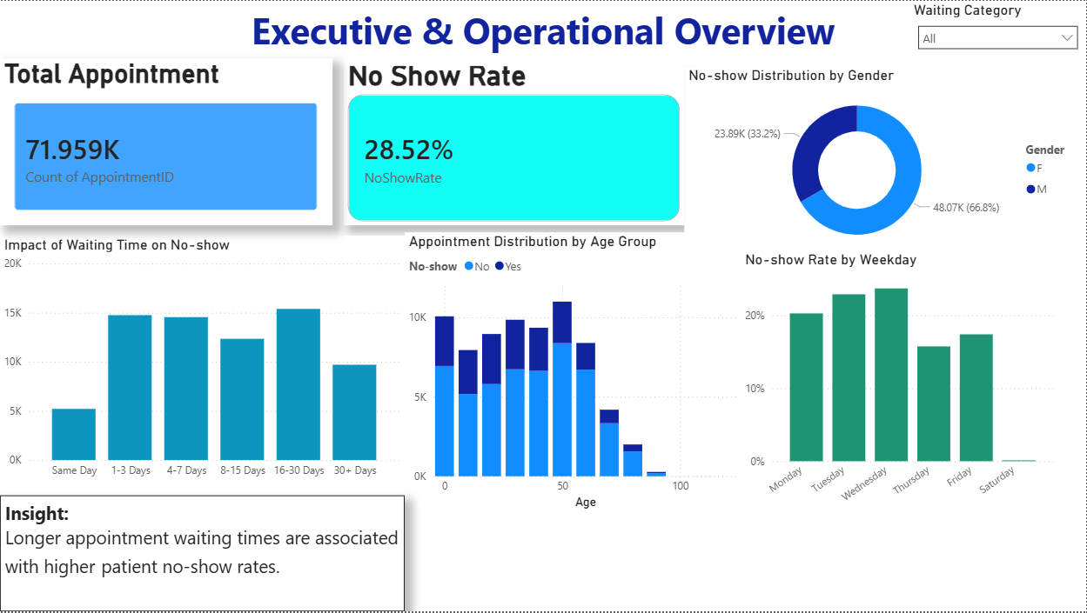 Figure 1: Executive & Operational Overview Dashboard — built in Power BI
The first dashboard provides a high-level operational summary for healthcare managers.
Key metrics displayed:
- Total Appointments: 71,959
- No-Show Rate: 28.52%
Charts included:
Impact of Waiting Time on No-Show (Bar Chart) Plots the number of no-shows by waiting time category. The 16–30 day bucket had the highest count, consistent with the notebook's finding that longer waits produce more no-shows.
Appointment Distribution by Age Group (Grouped Bar Chart) Shows how appointments are distributed across age groups with the no-show vs attended split visible for each band.
No-Show Distribution by Gender (Donut Chart) Male patients account for about 33.2% of appointments; female patients for 66.8%.
No-Show Rate by Weekday (Bar Chart) Shows variation in no-show rates across days of the week. Wednesday and Thursday stand out with higher rates.
Dashboard Insight: "Longer appointment waiting times are associated with higher patient no-show rates."
The dashboard also includes a Waiting Category filter dropdown that lets users slice all charts interactively.

7. Dashboard 2
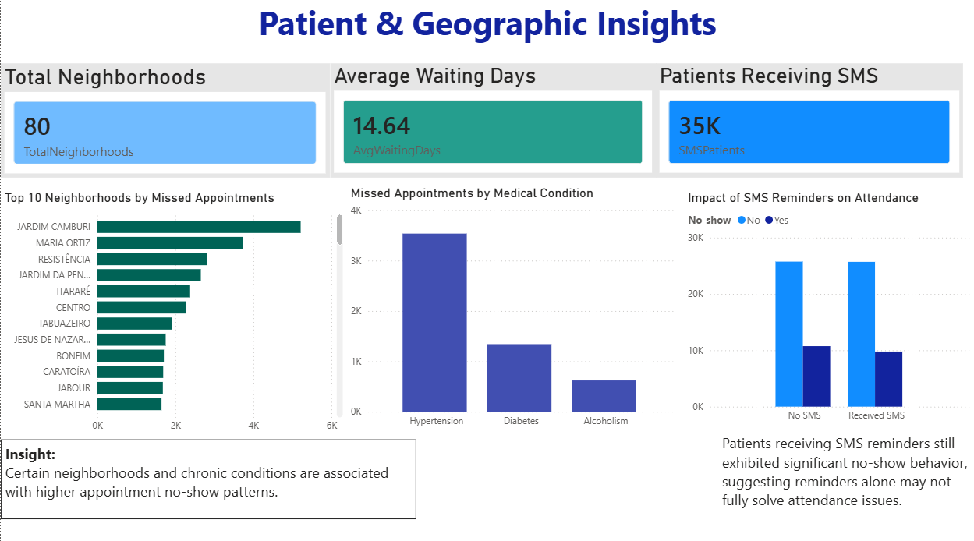Figure 2: Patient & Geographic Insights Dashboard — built in Power BI
The second dashboard focuses on geography and patient characteristics.
Key metrics displayed:
- Total Neighborhoods: 80
- Average Waiting Days: 14.64
- Patients Receiving SMS: 35K
Charts included:
Top 10 Neighborhoods by Missed Appointments (Horizontal Bar Chart) Jardim Camburi leads the list, followed by Maria Ortiz and Resistência. These neighborhoods were also flagged in the notebook's neighborhood no-show rate analysis.
Missed Appointments by Medical Condition (Bar Chart) Hypertension patients had the highest count of missed appointments, followed by diabetes and alcoholism.
Impact of SMS Reminders on Attendance (Grouped Bar Chart) Patients who received SMS reminders had nearly the same no-show counts as those who did not — consistent with the notebook's cross-tabulation findings. Reminders alone are not enough.
Dashboard Insight: "Certain neighborhoods and chronic conditions are associated with higher appointment no-show patterns."

8. Key Findings
1. Longer waiting time strongly correlates with higher no-shows. The no-show rate rose from ~21% for same-day appointments to over 33% for appointments booked 30+ days in advance.
2. Over a quarter of all appointments go unattended. A 28.52% no-show rate represents a significant operational inefficiency.
3. SMS reminders did not meaningfully reduce no-shows. The cross-tabulation and count plots showed that patients who received reminders still missed appointments at high rates.
4. Certain neighborhoods have disproportionately high missed appointments. The top 10 neighborhoods by no-show rate were identified and should be targeted for intervention.
5. Diabetes patients attended more consistently. Patients with chronic conditions like diabetes were comparatively more likely to attend their appointments.
6. Scholarship patients showed slightly different attendance behavior. Financial assistance enrollment was flagged as a useful segmentation variable for further analysis.

9. Recommendations
Based on the findings from the notebook and dashboards:
Reduce waiting times, especially for high-risk patients. The data clearly shows that same-day and short-wait appointments have much lower no-show rates. Clinics should aim to keep wait windows short wherever possible, and prioritize follow-up for appointments booked more than two weeks in advance.
Improve reminder strategies beyond SMS. Since SMS alone did not significantly reduce no-shows, clinics should consider phone calls, WhatsApp messages, or two-step reminders (one week before and one day before).
Target high-miss neighborhoods with outreach. Neighborhoods like Jardim Camburi and Maria Ortiz need dedicated interventions — whether that's transportation support, community health workers, or more accessible scheduling.
Use dashboard filters for smarter scheduling decisions. The cleaned dataset includes WaitingCategory, AgeGroup, ScheduledWeekday, and NoShowFlag — all of which are recommended in the notebook as dashboard filter dimensions for operational planning.

10. Conclusion
This project analyzed nearly 72,000 healthcare appointment records to understand what drives patient no-shows. After cleaning the data and engineering key features like WaitingDays, WaitingCategory, AgeGroup, and NoShowFlag, the analysis clearly showed that waiting time is the strongest factor associated with missed appointments — with no-show rates rising from 21% for same-day bookings to over 33% for those scheduled 30+ days out.
The two Power BI dashboards translate these findings into interactive, actionable views for healthcare administrators. Reducing no-show rates even modestly could have a meaningful impact on patient outcomes and operational efficiency — and the data points clearly to where those improvements should start.

Tools & Technologies Used: Python | Pandas | Matplotlib | Seaborn | Power BI
Dataset Source: Kaggle — Brazilian Medical Appointment Dataset (KaggleV2-May-2016.csv)

